Welcome To
Trinity Lutheran Church
Lutheran Church—Missouri Synod
A Stephen Ministry Congregation

1354 South Otsego Avenue
Gaylord, Michigan 49735
Church Phone: (989) 732-4816

Church Email: secretary@trinitygaylord.com
www.trinitygaylord.com

Office Hours: Monday through Friday 9am – 1pm

OUR PURPOSE
…is to LOVE GOD, LOVE OTHERS, AND SERVE THE WORLD by worshiping the Lord Jesus, bringing our members into Christ-like maturity, and equipping them through Word and Sacrament for their mission and ministry. We go heart to heart into the world with Jesus, sharing His love, caring for one another, praying, and bringing the lost into a relationship with Christ, by the working of the Holy Spirit.

October 23, 2022
Twentieth Sunday after Pentecost
Preacher: Rev. Ken Bernthal

ABOUT OUR WORSHIP
We welcome all who gather here today! We are blessed to celebrate together the mercy, grace, and love we have from God through the death and resurrection of our Lord Jesus Christ.

Children: Families with children are very welcome here. Having children in church is important so they can begin to learn about their faith in Jesus, and it’s good for the whole congregation to see. Please feel comfortable keeping “squirmy” kids in the service. This is where they belong, too!

Pew Cards: Guests and Members, please fill out the Guest/Member card located on the back of the pew in front of you and pass it to the end of the aisle. If you forget you can put it in the offering plate on your way out.

If standing is difficult: Please feel free to remain seated during any portion of the service. Please let an Elder or Usher know if you need communion in your pew seat.

About our celebration of Holy Communion: We celebrate the Lord’s Supper in the confession and glad confidence that, as he says, our Lord gives into our mouths not only bread and wine but his very body and blood to eat and to drink for the forgiveness of sins and to strengthen our union with him and with one another. Our Lord invites to his table those who trust his words, repent of all sin, and set aside any refusal to forgive and love as he forgives and loves us, that they may show forth his death until he comes.

Because those who eat and drink our Lord’s body and blood contrary to that which is stated above do so to their great harm, and also because Holy Communion is a confession of the faith which is confessed at this altar. Anyone who is not yet instructed, in doubt, or who hold a confession differing from that of the Lutheran Church—Missouri Synod, and yet desire to receive the sacrament, are asked first to speak with Pastor. Those not communing are still invited to come forward for a blessing from Pastor, and you may indicate this by crossing your arms over your chest.
TTTTTT
GREETING

P Peace be with you.
C And also with you.

T ORDER OF SERVICE T
(The liturgy is from Divine Service Setting four LSB pg. 203ff)

OPENING HYMN
Drawn to the Cross, Which Thou Hast Blessed LSB 560
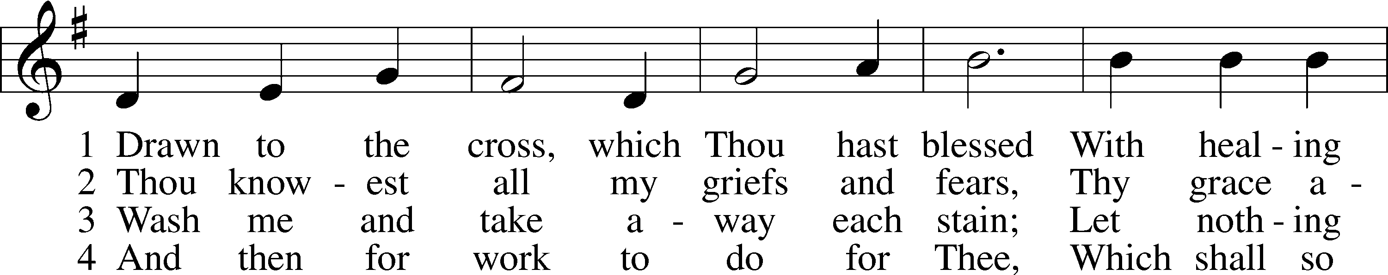
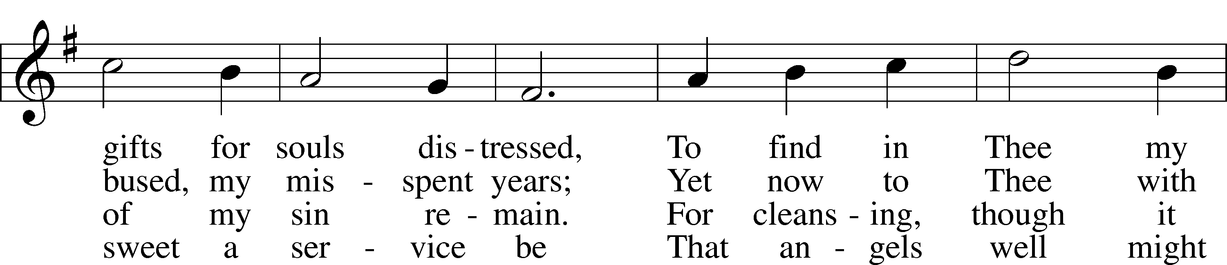
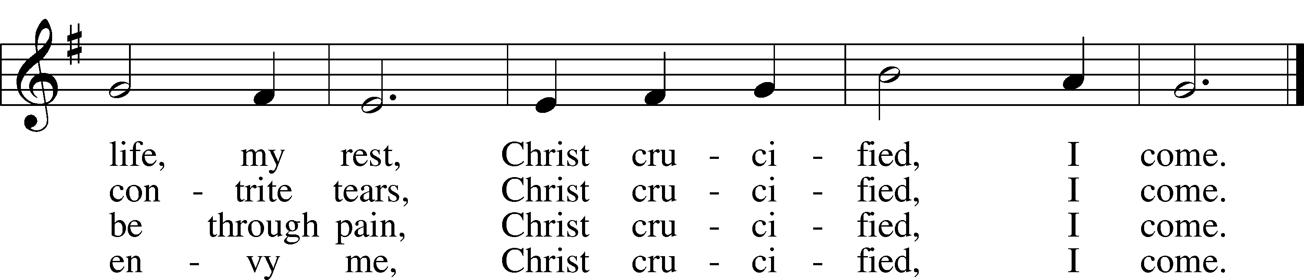

Please stand as able
CONFESSION and ABSOLUTION
The sign of the cross may be made by all in remembrance of their Baptism.

P In the name of the Father and of the T Son and of the Holy Spirit.
C Amen.
P Our help is in the name of the Lord,
C who made heaven and earth.
P If You, O Lord, kept a record of sins, O Lord, who could stand?
C But with You there is forgiveness; therefore, You are feared.
P Since we are gathered to hear God’s Word, call upon Him in prayer and praise, and receive the body and blood of our Lord Jesus Christ in the fellowship of this altar, let us first consider our unworthiness and confess before God and one another that we have sinned in thought, word, and deed, and that we cannot free ourselves from our sinful condition. Together as His people let us take refuge in the infinite mercy of God, our heavenly Father, seeking His grace for the sake of Christ, and saying: God, be merciful to me, a sinner.
C Almighty God, have mercy upon us, forgive us our sins, and lead us to everlasting life. Amen.
P Almighty God in His mercy has given His Son to die for you and for His sake forgives you all your sins. As a called and ordained servant of Christ, and by His authority, I therefore forgive you all your sins in the name of the Father and of the T Son and of the Holy Spirit.
C Amen.
T SERVICE OF THE WORD T
INTROIT
P When I am afraid,
I put my trust in you.
C In God, whose word I praise,
in the Lord, whose word I praise,

P in God I trust; I shall not be afraid.
What can man do to me?
C I must perform my vows to you, O God;
I will render thank offerings to you.
P For you have delivered my soul from death, yes, my feet from falling,
that I may walk before God in the light of life.

A Glory be to the Father and to the Son
and to the Holy Spirit;
as it was in the beginning,
is now, and will be forever. Amen.
P When I am afraid,
I put my trust in you.

KYRIE LSB 204
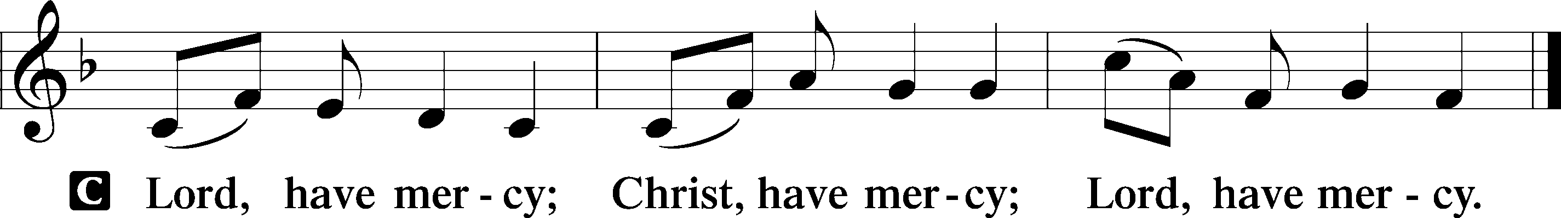

HYMN OF PRAISE
GLORIA IN EXCELSIS LSB 204
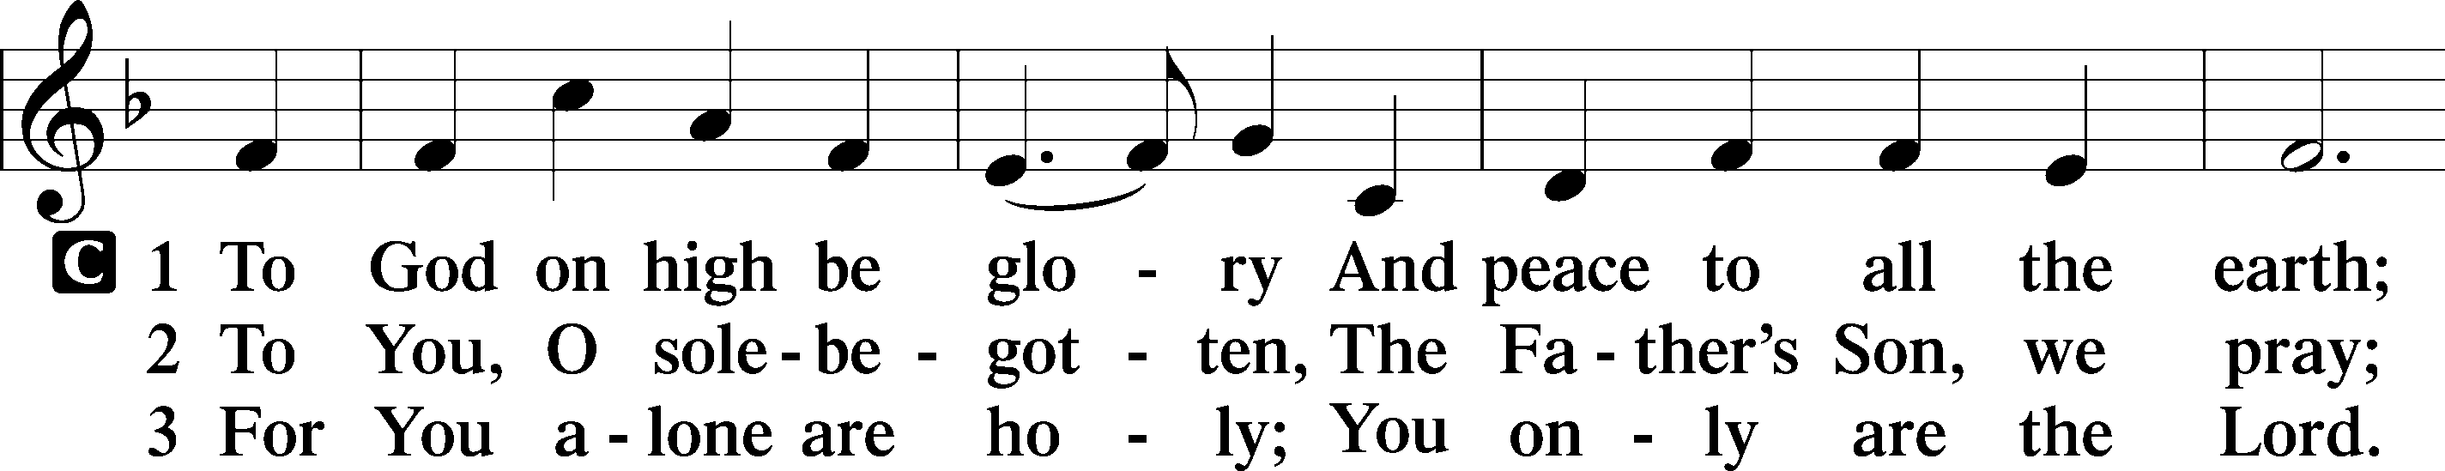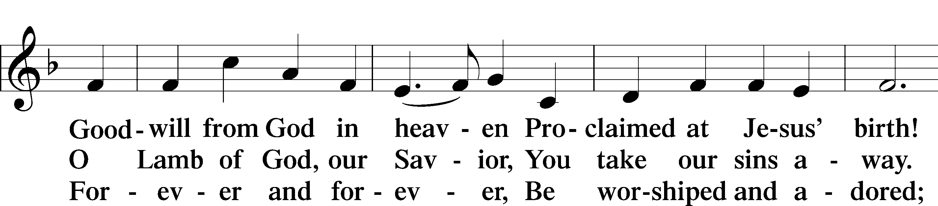
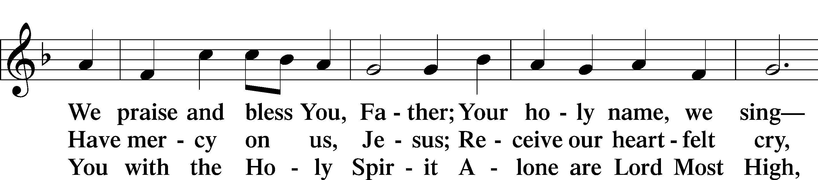
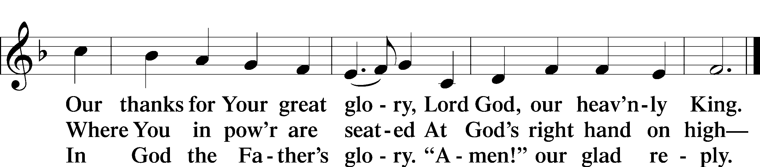

SALUTATION AND COLLECT OF THE DAY
P The Lord be with you.
C And also with you.
P Let us pray.
Almighty and everlasting God, You are always more ready to hear than we to pray and always ready to give more than we either desire or deserve. Pour down on us the abundance of Your mercy; forgive us those things of which our conscience is afraid; and give us those good things for which we are not worthy to ask except by the merits and mediation of Jesus Christ, Your Son, our Lord, who lives and reigns with You and the Holy Spirit, one God, now and forever.
C Amen.

Please be seated

OLD TESTAMENT READING Genesis 4:1–15
¹Now Adam knew Eve his wife, and she conceived and bore Cain, saying, “I have gotten a man with the help of the Lord.” ²And again, she bore his brother Abel. Now Abel was a keeper of sheep, and Cain a worker of the ground. ³In the course of time Cain brought to the Lord an offering of the fruit of the ground, ⁴and Abel also brought of the firstborn of his flock and of their fat portions. And the Lord had regard for Abel and his offering, ⁵but for Cain and his offering he had no regard. So Cain was very angry, and his face fell. ⁶The Lord said to Cain, “Why are you angry, and why has your face fallen? ⁷If you do well, will you not be accepted? And if you do not do well, sin is crouching at the door. Its desire is for you, but you must rule over it.”
⁸Cain spoke to Abel his brother. And when they were in the field, Cain rose up against his brother Abel and killed him. ⁹Then the Lord said to Cain, “Where is Abel your brother?” He said, “I do not know; am I my brother’s keeper?” ¹⁰And the Lord said, “What have you done? The voice of your brother’s blood is crying to me from the ground. ¹¹And now you are cursed from the ground, which has opened its mouth to receive your brother’s blood from your hand. ¹²When you work the ground, it shall no longer yield to you its strength. You shall be a fugitive and a wanderer on the earth.” ¹³Cain said to the Lord, “My punishment is greater than I can bear. ¹⁴Behold, you have driven me today away from the ground, and from your face I shall be hidden. I shall be a fugitive and a wanderer on the earth, and whoever finds me will kill me.” ¹⁵Then the
Lord said to him, “Not so! If anyone kills Cain, vengeance shall be taken on him sevenfold.” And the Lord put a mark on Cain, lest any who found him should attack him.
P This is the Word of the Lord.
C Thanks be to God.
EPISTLE 2 Timothy 4:6–8, 16–18
⁶For I am already being poured out as a drink offering, and the time of my departure has come. ⁷I have fought the good fight, I have finished the race, I have kept the faith. ⁸Henceforth there is laid up for me the crown of righteousness, which the Lord, the righteous judge, will award to me on that Day, and not only to me but also to all who have loved his appearing.
¹⁶At my first defense no one came to stand by me, but all deserted me. May it not be charged against them! ¹⁷But the Lord stood by me and strengthened me, so that through me the message might be fully proclaimed and all the Gentiles might hear it. So I was rescued from the lion’s mouth. ¹⁸The Lord will rescue me from every evil deed and bring me safely into his heavenly kingdom. To him be the glory forever and ever. Amen.

P This is the Word of the Lord.
C Thanks be to God.

Please stand as able

ALLELUIA AND VERSE
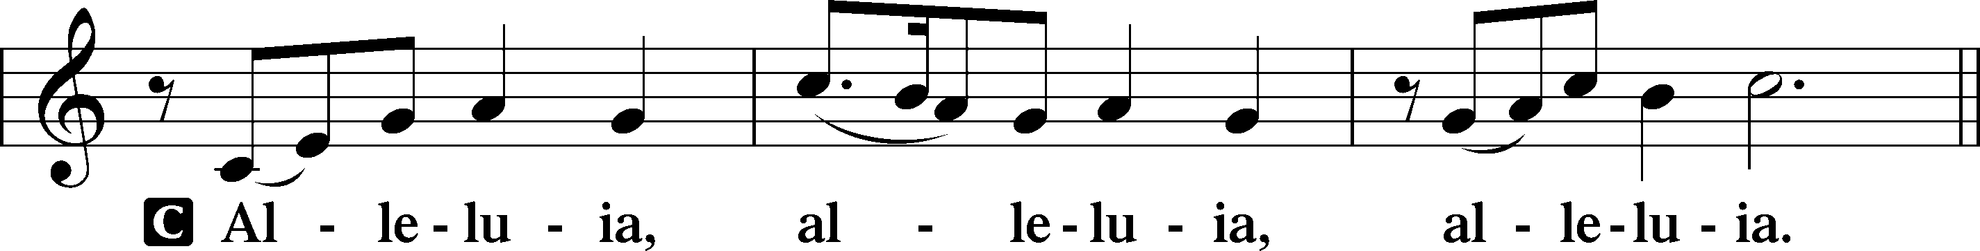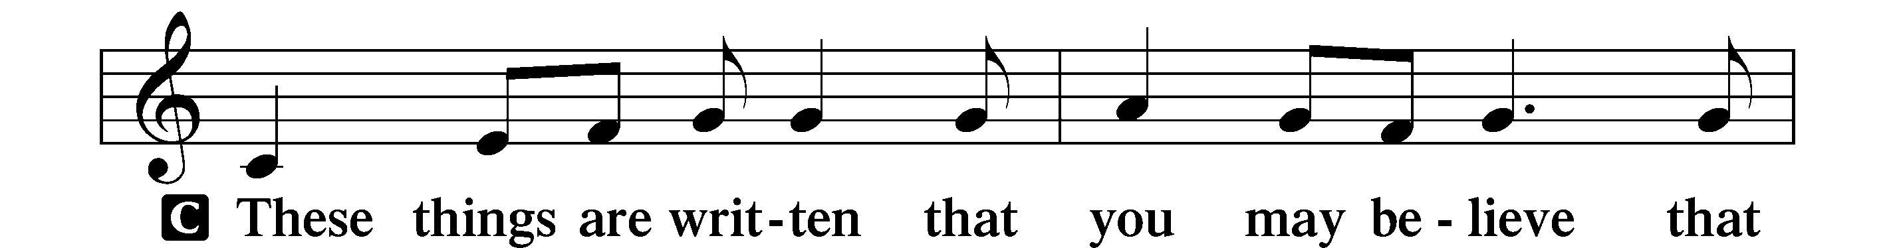
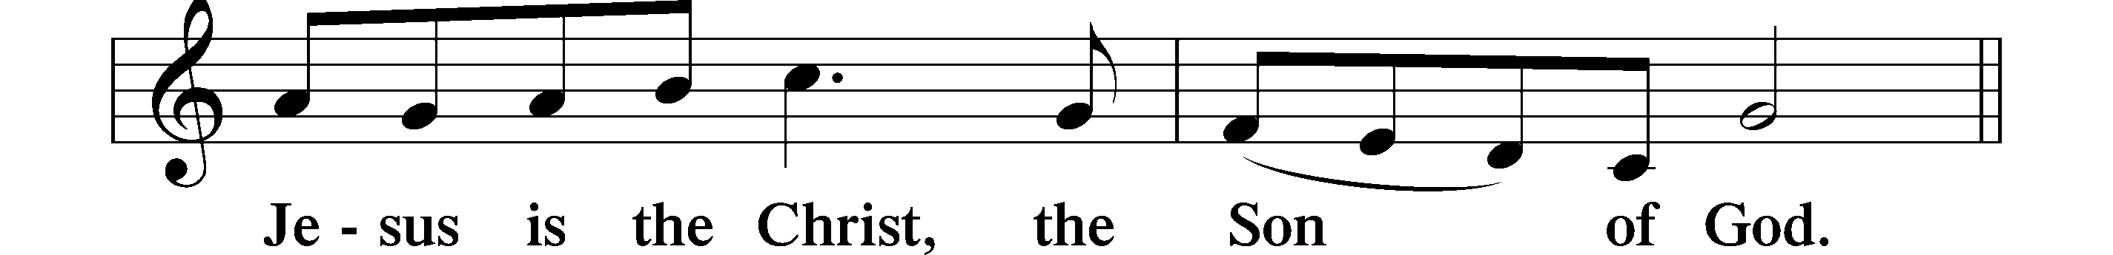
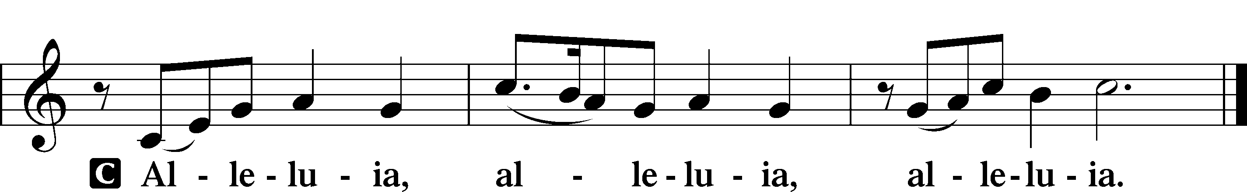

HOLY GOSPEL Luke 18:9–17
P The Holy Gospel according to St. Luke, the eighteenth chapter.
C Glory to You, O Lord.
⁹[Jesus] also told this parable to some who trusted in themselves that they were righteous, and treated others with contempt: ¹⁰“Two men went up into the temple to pray, one a Pharisee and the other a tax collector. ¹¹The Pharisee, standing by himself, prayed thus: ‘God, I thank you that I am not like other men, extortioners, unjust, adulterers, or even like this tax collector. ¹²I fast twice a week; I give tithes of all that I get.’ ¹³But the tax collector, standing far off, would not even lift up his eyes to heaven, but beat his breast, saying, ‘God, be merciful to me, a sinner!’ ¹⁴I tell you, this man went down to his house justified, rather than the other. For everyone who exalts himself will be humbled, but the one who humbles himself will be exalted.”
¹⁵Now they were bringing even infants to him that he might touch them. And when the disciples saw it, they rebuked them. ¹⁶But Jesus called them to him, saying, “Let the children come to me, and do not hinder them, for to such belongs the kingdom of God. ¹⁷Truly, I say to you, whoever does not receive the kingdom of God like a child shall not enter it.”
P This is the Gospel of the Lord.
C Praise to You, O Christ.

NICENE CREED
C I believe in one God,
the Father Almighty,
maker of heaven and earth
and of all things visible and invisible.
And in one Lord Jesus Christ,
the only-begotten Son of God,
begotten of His Father before all worlds,
God of God, Light of Light,
very God of very God,
begotten, not made,
being of one substance with the Father,
by whom all things were made;
who for us men and for our salvation came down from heaven
and was incarnate by the Holy Spirit of the virgin Mary
and was made man;
and was crucified also for us under Pontius Pilate.
He suffered and was buried.
And the third day He rose again according to the Scriptures
and ascended into heaven
and sits at the right hand of the Father.
And He will come again with glory to judge both the living and the dead,
whose kingdom will have no end.
And I believe in the Holy Spirit,
the Lord and giver of life,
who proceeds from the Father and the Son,
who with the Father and the Son together is worshiped and glorified,
who spoke by the prophets.
And I believe in one holy Christian and apostolic Church,
I acknowledge one Baptism for the remission of sins,
and I look for the resurrection of the dead
and the life T of the world to come. Amen.
Please be seated

ALL GOD’S CHILDREN – TALK

SERMON HYMN
Just as I Am, without One Plea LSB 570
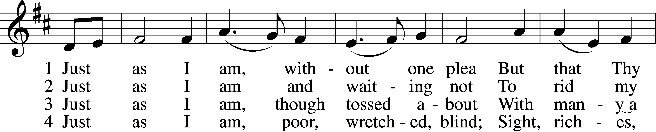
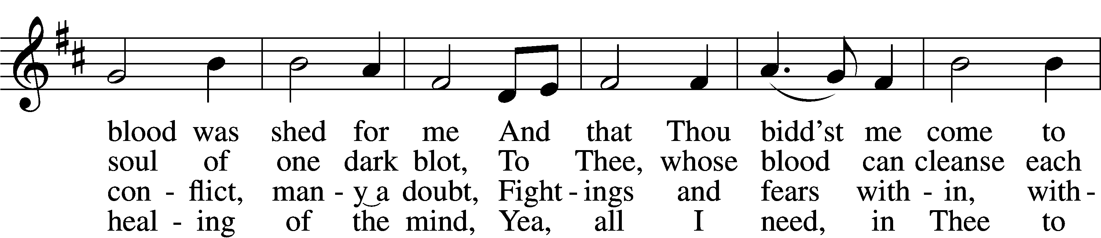
Continued on next page

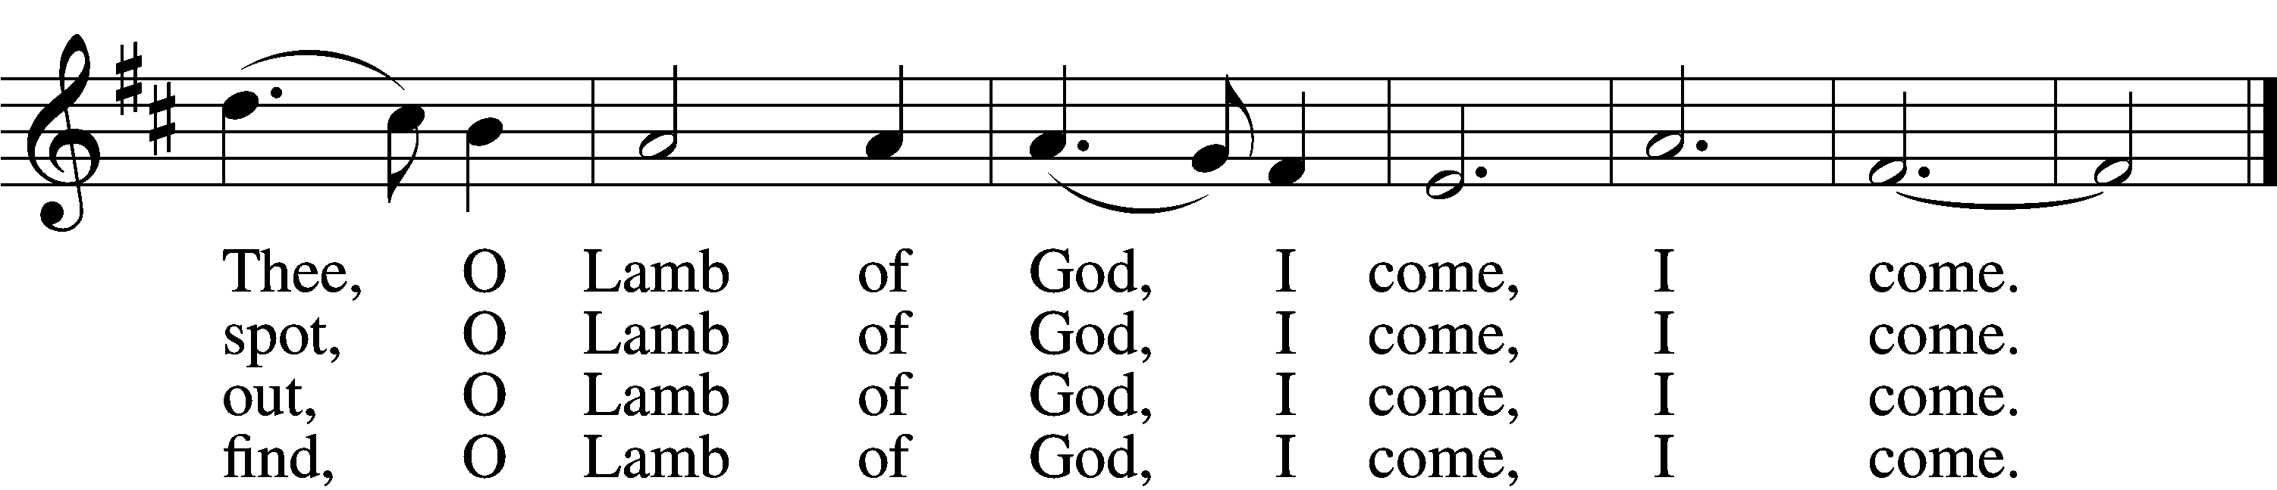

5 Just as I am, Thou wilt receive,
Wilt welcome, pardon, cleanse, relieve;
Because Thy promise I believe,
O Lamb of God, I come, I come.
6 Just as I am; Thy love unknown
Has broken ev’ry barrier down;
Now to be Thine, yea, Thine alone,
O Lamb of God, I come, I come.

SERMON
Please stand as able

PRAYER of the CHURCH
After each Segment:
P Lord, in Your Mercy,
C Hear our Prayer.
After Final Segment:
P Hear us as we pray in His name and as He has taught us:
LORD’S PRAYER
C Our Father who art in heaven,
hallowed be Thy name,
Thy kingdom come,
Thy will be done on earth
as it is in heaven;
give us this day our daily bread;
and forgive us our trespasses
as we forgive those
who trespass against us;
and lead us not into temptation,
but deliver us from evil.
For Thine is the kingdom
and the power and the glory
forever and ever. Amen.
T SERVICE of the SACRAMENT T

PREFACE LSB 208
P The Lord be with you.
C And also with you.
P Lift up your hearts.
C We lift them to the Lord.
P Let us give thanks to the Lord our God.
C It is right to give Him thanks and praise.
P It is truly good, right, and salutary that we should at all times and in all places give thanks to You, O Lord, holy Father, almighty and everlasting God, for the countless blessings You so freely bestow on us and all creation. Above all, we give thanks for Your boundless love shown to us when You sent Your only-begotten Son, Jesus Christ, into our flesh and laid on Him our sin, giving Him into death that we might not die eternally. Because He is now risen from the dead and lives and reigns to all eternity, all who believe in Him will overcome sin and death and will rise again to new life. Therefore with angels and archangels and with all the company of heaven we laud and magnify Your glorious name, evermore praising You and singing:

SANCTUS LSB 208
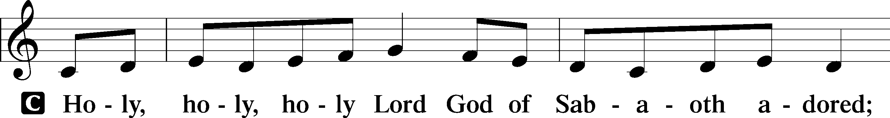
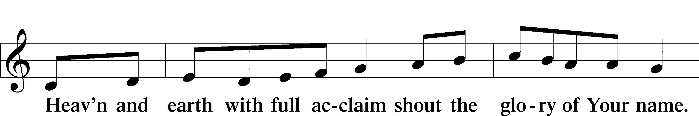
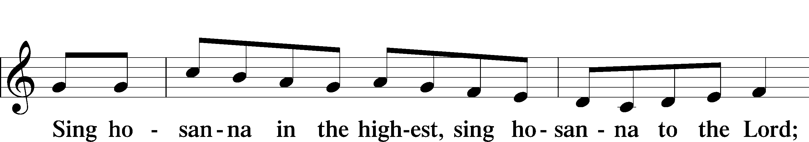
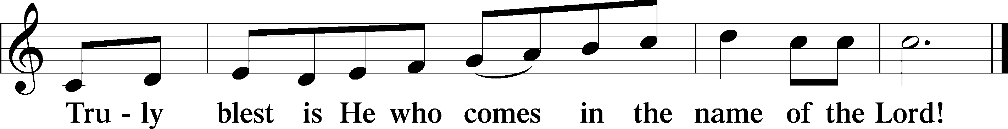

PRAYER OF THANKSGIVING
P Blessed are You, O Lord our God, king of all creation, for You have had mercy on us and given Your only-begotten Son that whoever believes in Him should not perish but have eternal life.
In Your righteous judgment You condemned the sin of Adam and Eve, who ate the forbidden fruit, and You justly barred them and all their children from the tree of life. Yet, in Your great mercy, You promised salvation by a second Adam, Your Son, Jesus Christ, our Lord, and made His cross a life-giving tree for all who trust in Him.
We give You thanks for the redemption You have prepared for us through Jesus Christ. Grant us Your Holy Spirit that we may faithfully eat and drink of the fruits of His cross and receive the blessings of forgiveness, life, and salvation that come to us in His body and blood.

THE WORDS OF OUR LORD
P Our Lord Jesus Christ, on the night when He was betrayed, took bread, and when He had given thanks, He broke it and gave it to the disciples and said: “Take, eat; this is My T body, which is given for you. This do in remembrance of Me.”
In the same way also, He took the cup after supper, and when He had given thanks, He gave it to them, saying: “Drink of it, all of you; this cup is the New Testament in My T blood, which is shed for you for the forgiveness of sins. This do, as often as you drink it, in remembrance of Me.”

PAX DOMINI
P The peace of the Lord be with you always.
C Amen.
AGNUS DEI
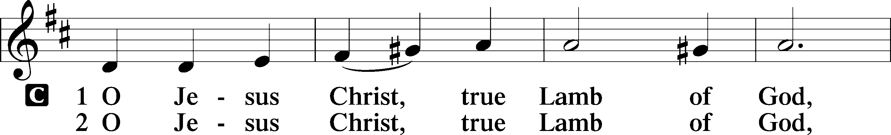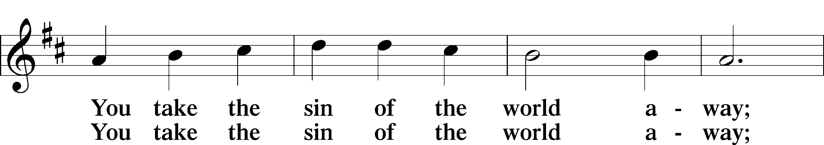
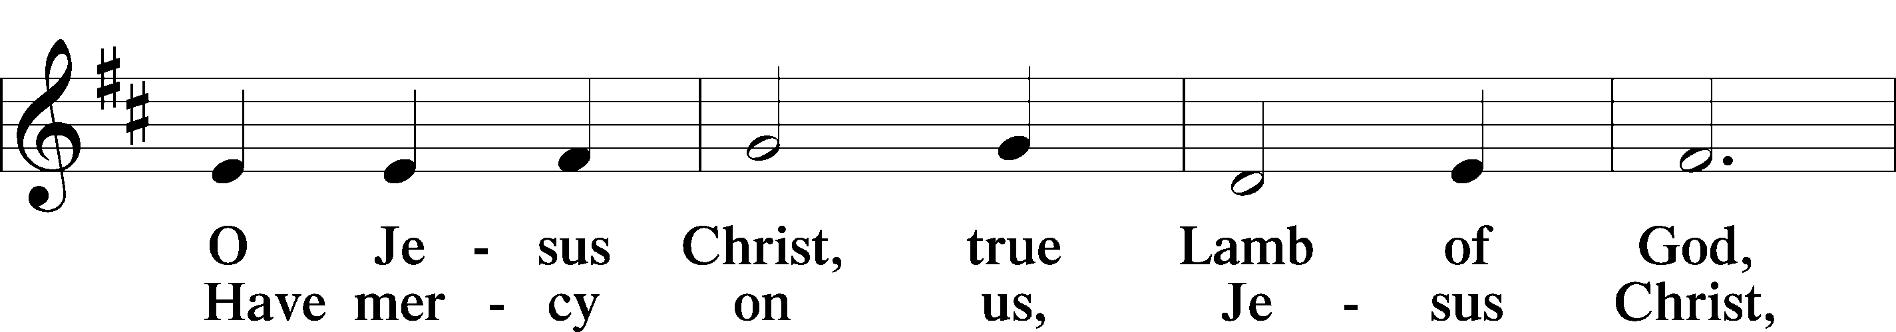
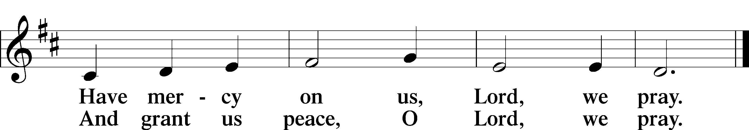

Please be seated
DISTRIBUTION
The pastor and those who assist him receive the body and blood of Christ first, then Communion will be served at the rail. Ushers will help direct you forward via the center aisle; please return to your seats via the side aisles. Gluten-free bread is available for those who need it, as is non-alcoholic grape juice. Simply request either when you come forward to receive Communion.
DISTRIBUTION HYMN
Jesus, Thy Blood and Righteousness LSB 563
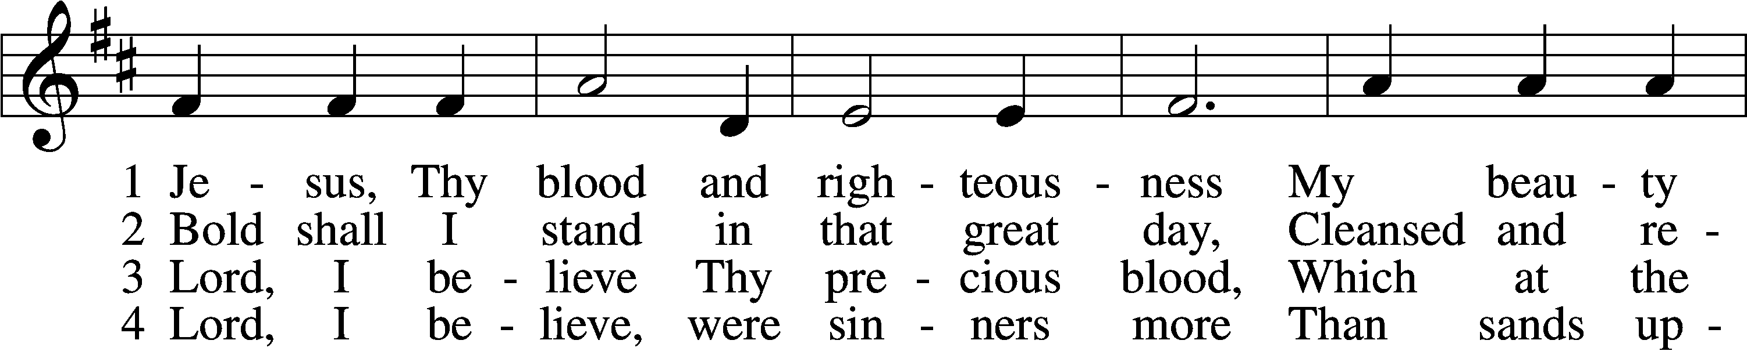
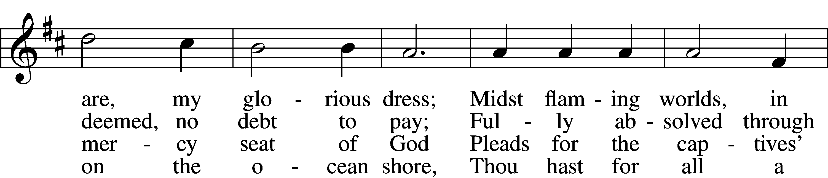
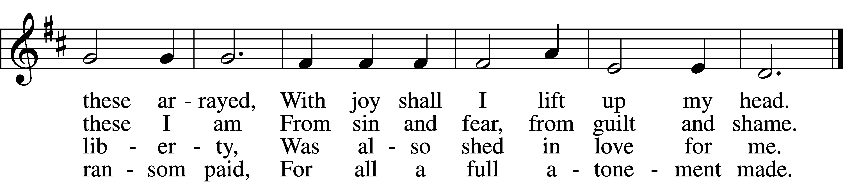
Verse 5-6 continued on next page
5 When from the dust of death I rise
To claim my mansion in the skies,
This then shall be my only plea:
Jesus hath lived and died for me.
6 Jesus, be endless praise to Thee,
Whose boundless mercy hath for me,
For me, and all Thy hands have made,
An everlasting ransom paid.

DISTRIBUTION HYMN
God Loved the World So That He Gave LSB 571 (Please stand on v.6)
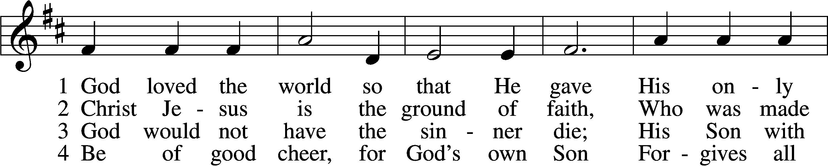
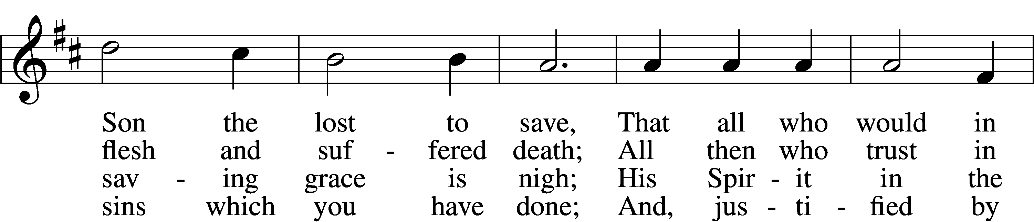
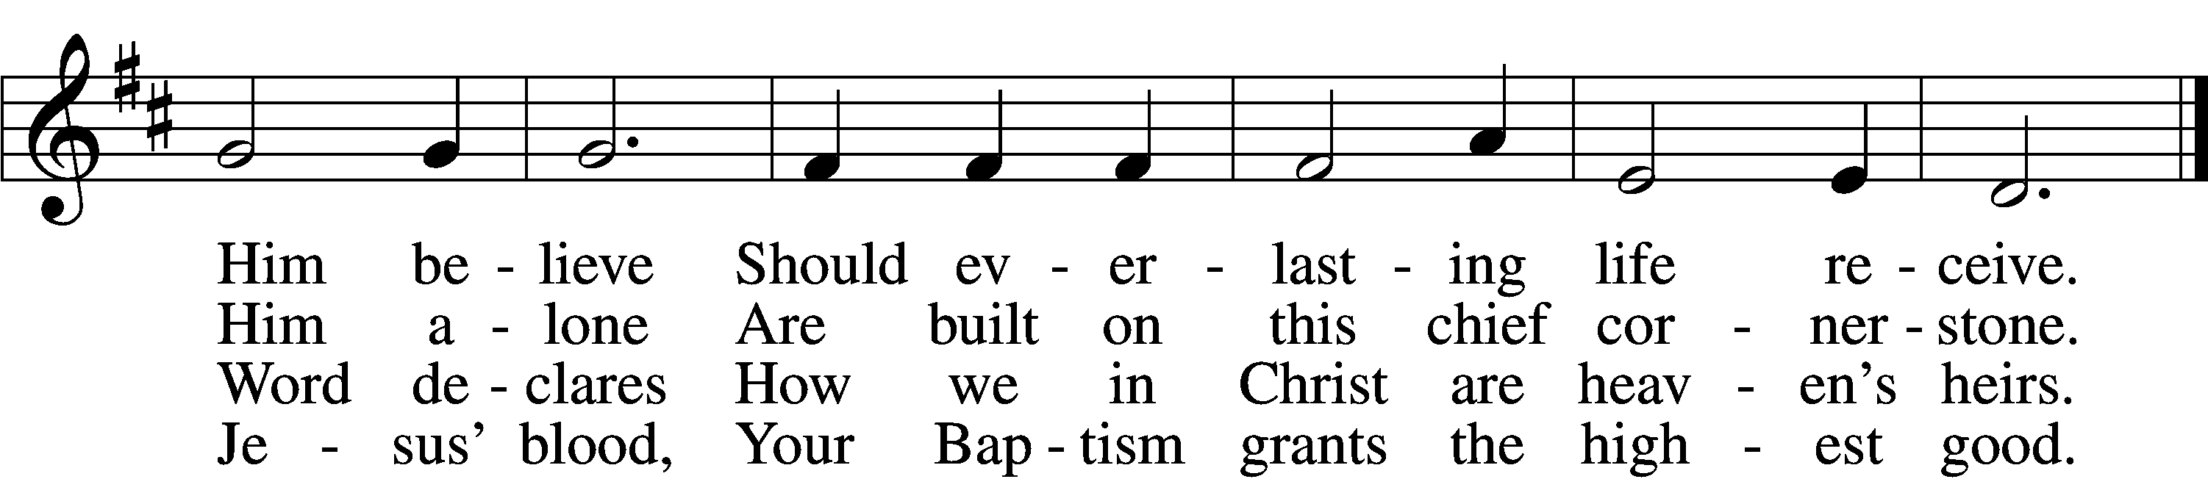
5 If you are sick, if death is near,
This truth your troubled heart can cheer:
Christ Jesus saves your soul from death;
That is the firmest ground of faith.
6 Glory to God the Father, Son,
And Holy Spirit, Three in One!
To You, O blessèd Trinity,
Be praise now and eternally!

NUNC DIMITTIS LSB 211
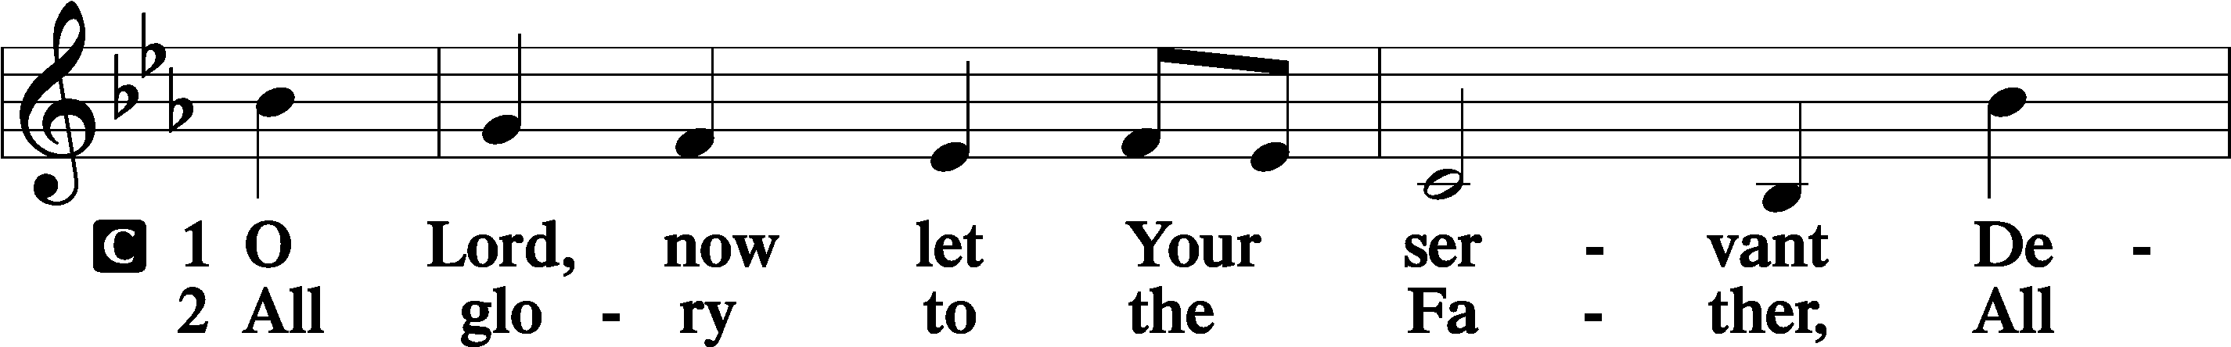
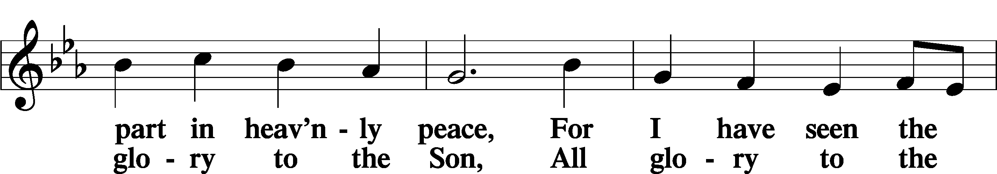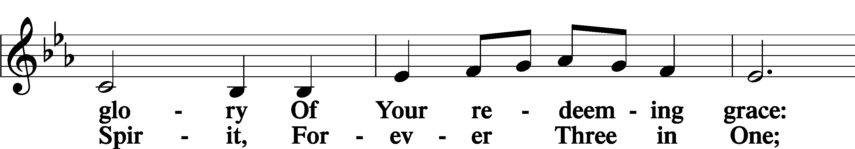
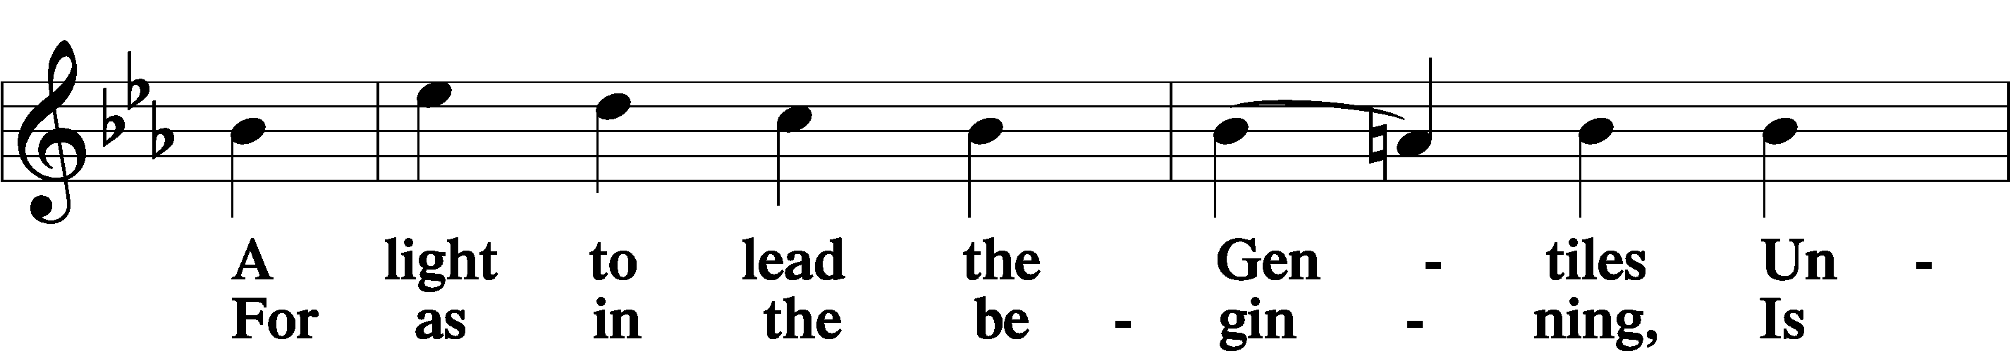
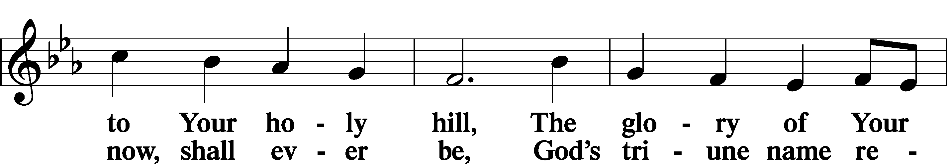
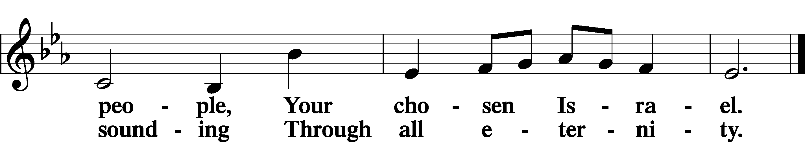

POST COMMUNION COLLECT
P Let us pray.
We give thanks to You, almighty God, that You have refreshed us through this salutary gift, and we implore You that of Your mercy You would strengthen us through the same in faith toward You and in fervent love toward one another; through Jesus Christ, Your Son, our Lord, who lives and reigns with You and the Holy Spirit, one God, now and forever.
C Amen.

BENEDICAMUS LSB 21
P Let us bless the Lord.
C Thanks be to God.
BENEDICTION
P The Lord bless you and keep you.
The Lord make His face shine on you and be gracious to you.
The Lord look upon you with favor and T give you peace.
C Amen.
Please be seated
CLOSING HYMN
Eternal Father, Strong to Save LSB 717
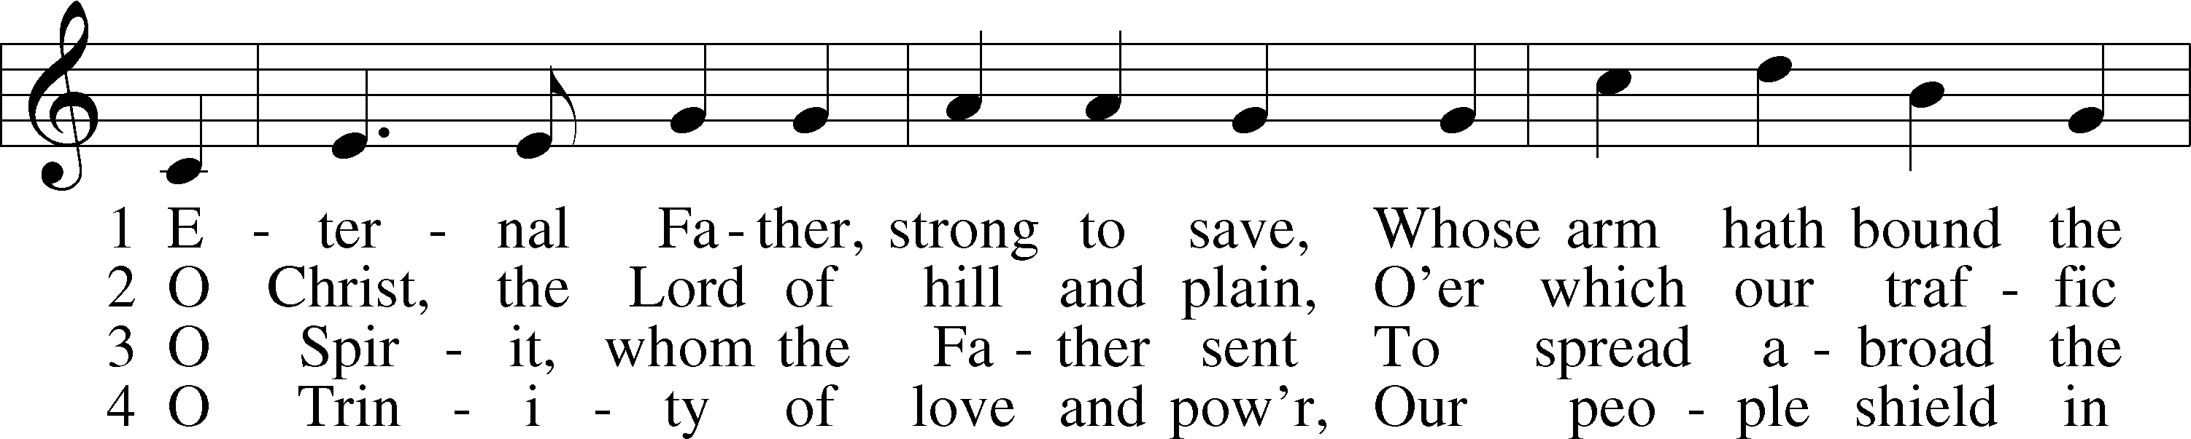
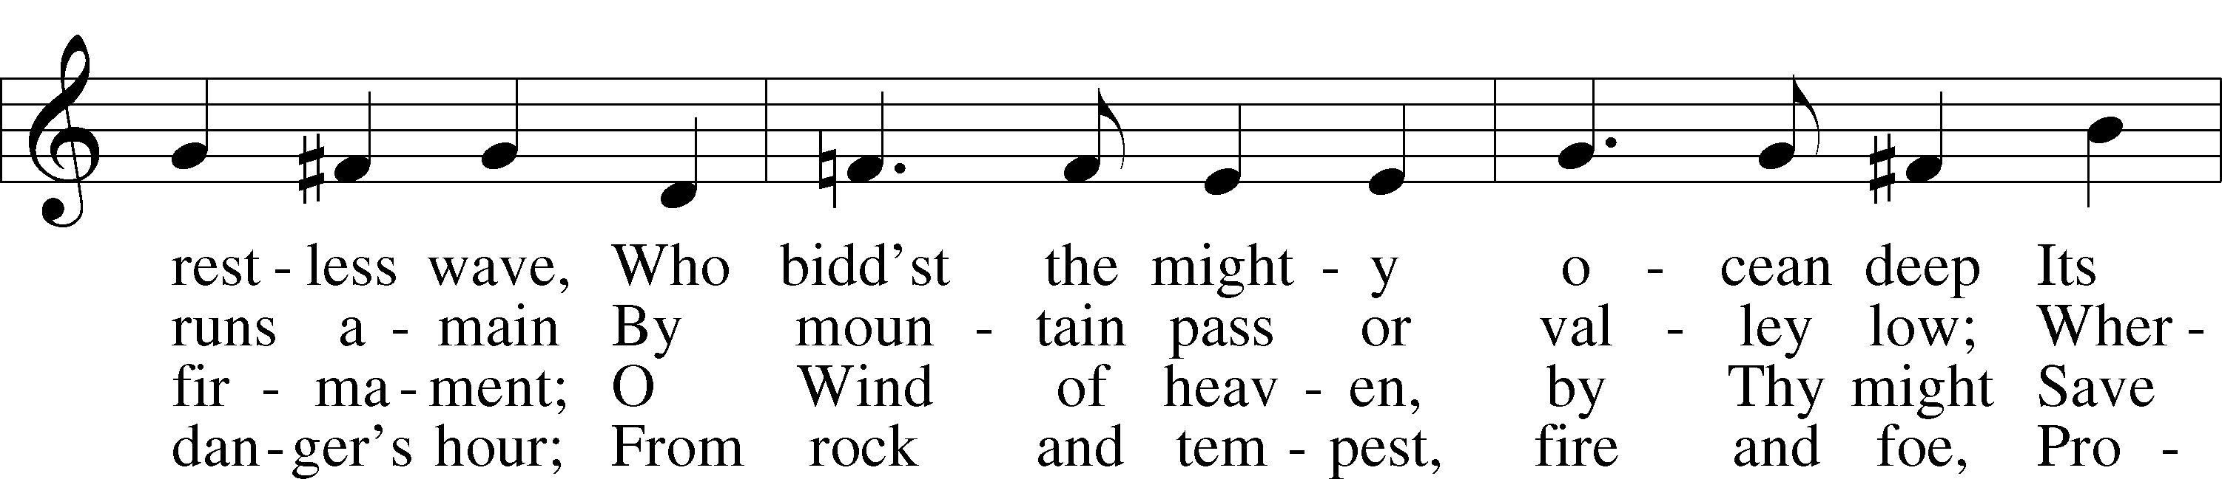
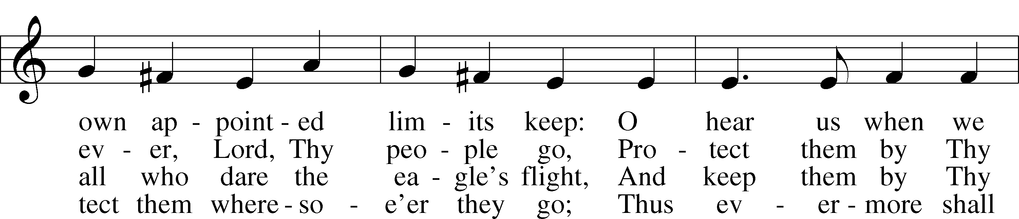
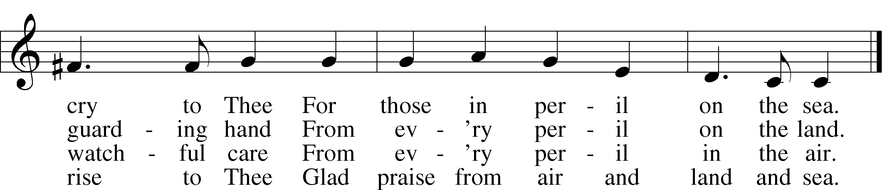
ANNOUNCEMENTS and SENDING WORDS
P We go to live for Jesus!
C We go to share His love!

Acknowledgments
Unless otherwise indicated, Scripture quotations are from the ESV® Bible (The Holy Bible, English Standard Version®), copyright 2001 by Crossway, a publishing ministry of Good News Publishers. Used by permission. All rights reserved. Created by Lutheran Service Builder. Music reproduced in this service is used with permission through: CCLI License No.1776588 and CPH – LSB Service Builder.

SERVING in GODS HOUSE TODAY`
Pastor: Rev. Ken Bernthal
Elder: Ken Mertz
Ushers: Jim & Marge Kunisch
Greeters: Joann Whitney
Counters: Janet Arner, Kathy Erat
Coffee Servers: Ken & Ann Mertz
Altar Care: Jeanine Boldrey
Organ/Piano: Tom /Jean Beach
Children’s Talk: Nancy Ely
Children’s Sunday School: Sharon Techel, Jean Beach and Nancy Ely
Sunday Morning Bible Study: w/ Dr. Tom Beach 10:30am
PRAYERS
Please contact the office with updates to the prayer list. People will remain on the prayer list for 4 weeks before being removed. If they need to remain on the list, please keep Elaine informed and of any updates. This will help us to have a more accurate list. Thanks for your cooperation.
Those who continue to grieve the passing of loved ones, The Family of Angela Perry, Family of Hilda Koch.
Those with upcoming surgery: Bill Stiles, and Greg Techel.
Those recovering from surgery: Roxy Mohr, Joann Whitney, and Jim (Joann Whitney’s brother-in-law).
Those with health concerns: Tiffany Amsdill, Wally Beasinger, Ruth Bennett (Sharron Kato’s Sister), Tanner Beyers, Hope Buchinger, Betsy Cook, Kay Gregg, Paul Kietzman, Jennifer Martin, Eleanor Raether, Beth Smith, Judi Stutzman, and Elizabeth (the niece and granddaughter of Jennifer and Leslie Martin) she is having some serious reproductive problems and is waiting for more answers.
Those diagnosed with cancer: Sue Cavanagh (diagnosed with breast cancer). Leah Eicher, Rachel Frisch, Janice Knoellinger, Leslie Martin, Brian Morgan, and Hope Osantowski.
Those under Hospice Home Care: Ken Williamson, Jim (Joann Whitney’s brother-in law).
BIRTHDAYS: ANNIVERSARYS:
10/23 Eleanor Raether 10/26 Tom and Terri Raithel
10/28 Janet Arner 10-26 Alan & Nicole Tucek

MESSAGES
ALTAR FLOWERS ALTAR FLOWERS today is given to the glory of God by Tom & Terri Raithel’s 43rd anniversary.
MEMBER & GUEST CARDS: If you have not filled out a member/guest card, please take the time to fill one out and place it in the plate behind the back pews in our sanctuary.
GREETING CARDS If you are in need of some greeting cards, we carry an array of them. The card cabinet is in the hallway across from the library. The cost of the cards is posted on the cabinet. The money collected from the cards goes to LWML to help support Missions.
CHURCH EXTENSION FUND has proven investment products with measurable results. Since 1901, through dedicated Christian financial management, CEF is focused on funding the needs of Michigan District congregations. (Proven, Dedicated, Focused)
For more information, contact (Congregation Representative and telephone number) or call 800-242-3944.
WEDNESDAY MORNING BIBLE STUDY 10:00am w/ Rev Ken Bernthal (Fellowship Hall.)
CANCER & FRIENDS SUPPORT GROUP meet the 4th Tuesday of each month at 5:30pm in the church fellowship hall. If you are a patient, survivor, spouse, family, friend, or a caregiver you are all welcome to attend the meetings. We can all help each other. Hope to see you at the meetings, everyone is invited. I will have more information it in the bulletin or the October meeting You can call or contact Elaine Raschke by email elaineraschke@gmail.com, you can also call or text at 989-350-4391

SUNDAY MORNING BIBLE STUDY 10:30 am with Dr. Tom Beach.
PORTALS OF PRAYER: For October- December are the shelf in the narthex, please feel free to take one.
TRUNK OR TREAT: Monday October 31ST in the church parking lot, if it rains it will be held in the Church. Everyone is welcome to participate in the event. We are also in need of some candy donations to hand out to the children if you can donate any please put it in the box under the shelf in the Narthex. If you would like to join us, please do, We can always use help passing out candy. I'll have a sign up sheet in the Narthex along with a box for donations this Sunday but I do have to work at 10 so I'll be leaving early.
Thank you
Sharon Techel

KUT-UPS: the dates for this year are as follows:
Oct. 24 Nov.7 and 21 Dec. 5 and 19

CHILDRENS ACTIVITIES BAGS The activity bags are now set up for the young children, they are located on a stand next to the worship folders as you cone in the s

SERVING in GODS HOUSE NEXT WEEK REFORMATION SUNDAY 10/30/2022
Pastor: Rev. Paul Schneider
Elder: Dave Beyers
Ushers: Larry & Joann Whitney
Greeters: Pam & Wally Beasinger
Counters: Brian Techel, Karl Scheiterlein
Coffee Servers: Tom & Terry Raithel
Altar Care: Kathy Erat
Virtual Organ: Bob Erat
Children’s Talk: Nancy Ely
Children’s Sunday School: Sharon Techel, Jean Beach and Nancy Ely
Sunday Morning Bible Study: w/ Dr. Tom Beach 10:30am

THIS WEEK AT TRINITY
October 23 Sunday
9:00 am Worship Service -Rev. Ken Bernthal
10:00 am Fellowship & Coffee Hour
10:30 am Sunday Morning Bible Study W/Dr.Tom Beach
10:30 am Children’s Sunday School
October 24 Monday
NEWSLETTER DEADLINE
10:00 am Kut-Ups
7:00 pm Choir
October 25 Tuesday
5:30 pm Cancer & Friends Support Group (Fellowship Hall)
October 26 Wednesday
10:00 am Wednesday Morning Bible Study W/ Pastor Ken Bernthal
October 27 Thursday
October 28 Friday
October 29 Saturday
October 30 Sunday
9:00 am Worship Service - Rev. Paul Schneider
Reformation Sunday
Noisy Offering
10:00 am Fellowship & Coffee Hour
10:30 am Bible Study with Dr. Tom Beach
10:30 am Children’s Sunday School

